Automated Mapping of Snow Cover on Swiss Glaciers with Sentinel-2: Data Processing and Analysis

# Abstract < 1 page

Inhalt

Abstract < 1 page 1

Introduction: 4

Current State of reseach in the field 6

Rastner: 7

Naegli: 8

Potential Improvements: 10

Current state of own research and Methodology 10

Sensor and Data 10

Preprocessing: 11

General Tests of Bandcombinations: 13

Testing Algorithms 13

Goal 15

Challenges for automatization 16

Time Plan- Schedule and milestones 17

Impact / Conclusion 18

Reference & Literature (Bibliography) 18

**​**

# Introduction:

The rapid of the Swiss glaciers is a good indicator of climate change and warming in the Alps. To better quantify their decreasing extend and gain knowledge about their behavior in the future, mass balance models are widely applied in Glaciology.

For the Swiss glaciers, the CRAMPON project (Cryospheric Monitoring and Prediction Online) is developing an operational modeling tool to nowcast and predict mass balance and runoff to provide a near-real-time source of information on their current state and determine their behavior in the future.

For the determination of the mass balance of a glacier, i.e. the sum of how much mass a glacier is gaining, e.g. due to precipitation or losing, e.g. due to melt at any time, the amount of snow cover on the glacier and the corresponding snow line altitude (SLA) can provide valuable information.

To improve the mass balance nowcasting, the position of the corresponding transient snow line (TSL) can be used for the calibration of melt models: Therefore, the information given by the temporal variability of the TSL during the summer is employed to constrain the amount of melt by iteratively calibrating a temperature index melt model (Barandun et al., 2017).

The other use of this information in the CRAMPON project is for an online assimilation of snow-covered area to enhance the accuracy of estimated melt.

With the rapidly increasing availability of free, high-resolution satellite image data with revisiting periods within in the range of days, new possibilities to employ this data in remote sensing applications arise. In this project, we will make use of the Sentinel-2 optical data to capture the varying snow cover of the Swiss Glaciers every 5 days, depending on cloud cover in the areas. With this approach, we will be able to achieve a series with high temporal resolution as an input for the CRAMPON project.

To be able to incorporate this information in a nowcast and mass balance prediction model in a long term, an optimal mapping algorithm needs to be found and incorporated as an automated process.

To achieve this goal, the characteristics of the spectral response of snow in certain wavelength regions of the visible and near-infrared part of the solar spectrum need to be employed in an algorithm as they are the key for a successful classification of snow and ice on glaciers.

As it can be seen in figure 1, the spectral response of ice and snow is highly varying and depends on many different parameters such as age of snow, water content, grain size, impurities, etc. and it is therefore difficult to determine the type of surface cover only by its reflectance.

In general, snow has a high reflectance in the visible (VIS) wavelengths (400 to 700nm) of over 0.9 whereas pure ice with a reflectance of around 0.6 reflects still much more than dirty glacier ice. This behavior can be explained by the fact that in the VIS range the reflectance is mostly influenced by impurities on the surface (Warren 1980).

For glacier ice the VIS reflectance in the longer infrared (IR) wavelengths (over 700 nm), the reflectance decreases significantly, while for ice the decrease is much stronger with a steeper slope. This is due to effect that the grain size affects the behavior in the middle infrared region, leading to a strong decrease for larger grain sizes (Wiscombe and Warren 1980). This characteristic of a different slope of the reflectance in the near-infrared range can be used to distinguish between snow and ice in remote sensing data. (Dietz 2011).

To distinguish between snow and other land surface types or clouds, one commonly applied method is the Normalized Difference Snow Index (NDSI), first introduced by Hall, 1995, that employs the characteristic slope between the high VIS and the low SWIR reflectance of snow in a ratio between those two bands depending on the specific satellite used. For Sentinel-2 Data those are Bands 3 and Band 11 and the NDSI is defined as NDSI = (B3-B11)/(B3+B11). For the classification, usually a set of fix thresholds are applied, e.g. classifying pixels with an NDSI over 0.2 as snow or applying a more complex decision tree also including cloud characteristic as well as other bands as it is done e.g. by ESA’s automatic scene classification (Sentinel-2 Technical Guide).

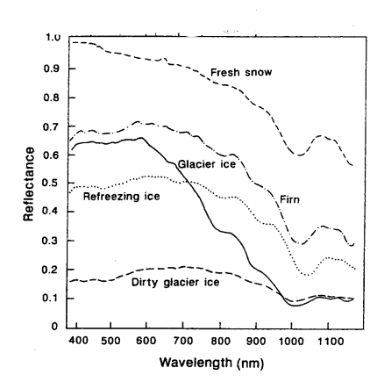

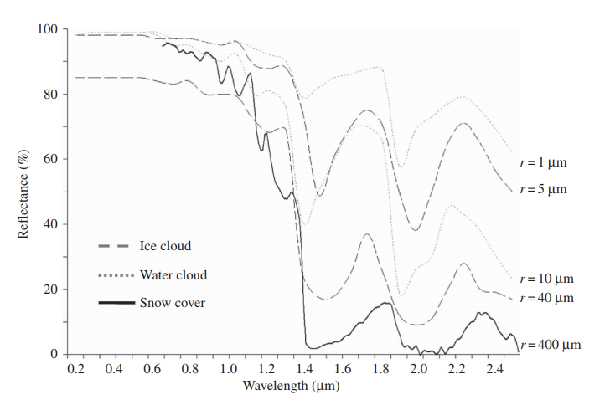

Another major challenge in snow cover mapping is to be able to discriminate between clouds and snow since they exhibit a very similar spectral behavior in the visible and thermal range. There is one characteristic that can be used to discriminate snow and clouds are the grain size of the particles, whereas water drops and ice particles in clouds have much smaller grain sizes (10 micrometer and 40 micrometer) than typical snow grains (400 microm). This leads to a stronger decrease in reflectance of snow particles in the shortwave infrared (SWIR) than for clouds and can therefore be used to detect clouds over snow (Dietz 2011). However, even though the correct detection of clouds is a difficult but crucial point to properly detect snow cover, it is not the focus of this thesis. We therefore will simply try to find the best state-of-the-art cloud cover algorithm based on previous studies that is suitable for our needs and implement it in the workflow (more on the cloud masks in Methodology).

With this knowledge about the spectral characteristics of ice and snow, the goal of this master thesis is to set up an object-oriented programming framework that finds an automated preprocessing chain of Sentinel-2 images, maps and validates the snow cover on all glaciers using a multi-spectral classification algorithm. To find an appropriate algorithm, several different approaches following state-of-the-art of snow classification will be implemented and a set of different band and band ratio combinations will be tested.

To determine the best working algorithm, a statistical analysis with a focus on spatio-temporal variability of snow covered area on the Swiss glaciers will be conducted.

# Current State of reseach in the field

A classical approach for scene classification such as ice and snow in optical satellite imagery, the classical optical remote sensing approach would be to look at different bands, band ratios and combinations, trying to combine those in different manners, based on the spectral properties of the area that needs to be extracted and then apply one or a series of certain thresholds to discriminate between the different types of land cover.

This approach has been widely applied to discriminate between snow and land surface (see Paul et al. 2015, Paul 2016, König 2015 for a review), often using thresholding on simple bands, band ratios, differential ratios such as the NDSI or combinations of the three.

Many of them have manually been applied successfully to map glacier extends (Paul 2016) and some have even been implemented into an automated workflow (e.g. the SNOWMAP algorithm for MODIS, Hall et. al 1995 or the snow scene classification of Sentinel-2 Level 2 A data). This means that for simple snow mapping the contrasts are usually high enough to obtain good results with a thresholding approach of varying complexity.

To obtain suitable combinations of bands and thresholds, there are different approaches: either a differential band ratio as the NDSI that is based on the characteristics of the spectral reflectance of ice and snow or making a “sophisticated guess” by trying out different sets of bands and visually or statistically checking which ones yields the best results (Paul 2016). In the recent past there has been some effort to use machine learning to find the best band combinations and thresholds for an automated classification (e.g. Bonev, 2017 or the Sentinel-2 scene classification algorithm).

As good as those methods work for general snow classification, the discrimination between snow and ice faces some more challenges. Since their spectral reflectance is much more similar than that of snow and other land cover, influences like e.g. terrain or cloud shadows especially in mountainous terrain often create higher contrasts than the contrast between snow and ice. Therefore, using simple band ratios or differential bandratios like the NDSI, that can correct for terrain induced illumination differenced to some extend are not successful for snow and ice mapping (Khan 2014, Paul, 2016). Also applying other band combination can’t correct for the terrain shadows.

Therefore, a careful preprocessing and correction of this information with secondary information like a DEM becomes crucial for any successful classification.

Paul 2016 describes a simple approach to map snow on an Alpine glacier with Sentinel-2 data by preprocessing them with the Ekstrand terrain correction and then applies a manually adapted threshold to the NIR Band based on the approach by Bippus, 2011, achieving reasonable results.

Unlike the wide variety of band combinations used for general snow classification, the contrast between snow and ice is often already well resolved in e.g. the NIR band, but can still be enhanced by using several bands.

Rabatel et al, 2012 used a combination of the green, NIR and SWIR to derive the SLA on glaciers in tropical areas, as this combination, when applying thresholds on the NIR ands green band, gives the best visual contrast from different combinations he tried. The thresholds depend on lighting conditions on the acquisition date for each image, which require manual supervision. According to Rabatel, the result allows a clear manual delineation of the snow line, but still can’t resolve the terrain shaded areas higher up the glacier, that would problematic for a potential automated approach. However, they provide no statistical analysis of their results against a manually mapped snow cover, only optical evaluation and comparison against field data that revealed a good match. This approach has also been applied by many others in the Himalaya, the Tropics and the Alps (Veettil 2014, 2015, Rabatel 2015 and Presentation).

With the knowledge that only analyzing band combinations won’t lead to a successful automated classification of snow cover on glaciers, the requirements for an automated algorithm are different than for a simple snow classification. It needs to find a way to account for the high contrast induced by terrain shadows, either by applying the best achievable terrain correction with a DEM or finding other ways to employ the typical shape of a glacial snow cover to correct for those effects. There are two algorithms that were developed recently and that this thesis will implement for Sentinel-2 data.

The first one presented by Rastner, 2018 (paper still under review), applying the Otsu-algorithm that finds an individual optimum threshold for each NIR band that maximizes the inter-class variance and minimizes their combined spread.

The other algorithm by Naegli, 2018 (paper still under review) focuses on the shortwave broadband albedo in a multi-step classification scheme including the glacier geometry and altitude to retrieve the bare-ice area versus snow-covered surfaces.

## Rastner:

The ‘ASMAG’ (Automated snow mapping on glaciers) (figure 3) algorithm that Rastner developed uses 63 Landsat scenes that were processed individually to detect the snow-covered area and the SLA for each scene. For the processing, the required input consists of all Landsat satellite bands, a digital elevation model (DEM) containing all glaciers that is derived from several available DEMs and manually derived glacier outlines.

The Landsat imagery undergoes extensive pre-processing, converting radiance bands to reflectance bands. This, the sun incidence angle, the slope, aspect and a hill shade of the input DEM is located and used to apply an Ekstrand correction only to the NIR band (Ekstrand, 1996).

From the thermal band, the brightness temperature is derived and applied on bright areas to determine if they are snow(cold) or clouds(warmer). This way, a cloud mask is created that is applied individually for each scene and only scenes with less than 10% cloud cover are processed by the algorithm.

The actual thresholding of the ASMAG is then performed on the NIR band for each glacier individually using the Otsu-threshold. It assumes that the scene’s histogram is bimodal, having two peaks that correspond to ice and snow and now find the optimal threshold that maximizes the inter-class variance and minimizes their combined spread. Applying this threshold to the scene gives a direct bimodal snow cover map of the area. In order to retrieve the snow line altitude in ASMAG, the applied DEM is split into 20 m elevation bins with which the snow-cover map from the previous step is intersected. If the first (lowest) five elevation bins all have a snow cover larger than 50%, the lowest of these bins is selected as the SLA. If not, the iteration is repeated for the next higher set of five bins. If there are no five continuous bins that meet that criterion throughout the entire glacier, the same test is repeated for four, three, two or one bin to retrieve the SLA.

One limitation of this approach for all Swiss glaciers is the presence of very small glaciers that are often either completely snow covered or completely snow-free. Since the Otsu-Algorithm will always assume a bimodal histogram for each glacier this method will fail to correctly map the snow cover of those glaciers. However, since their area is rather small, the question is how much they contribute to the overall mass balance of all glaciers and how relevant this shortcoming is.

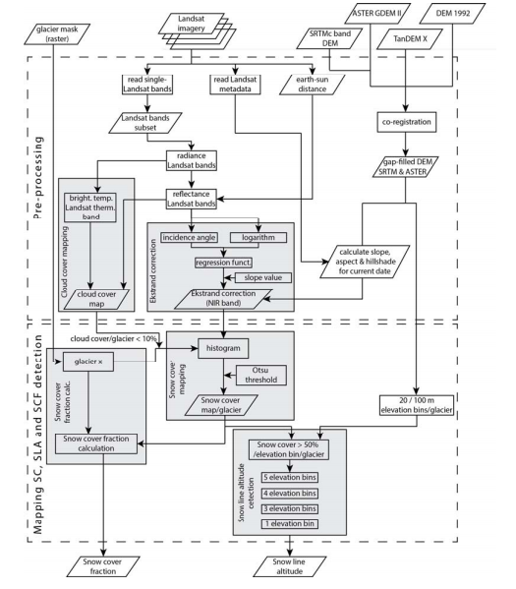

## Naegli:

In Naegli 2017, a method to retrieve the remotely determined end-of summer albedo of Swiss glacier ice is described. It uses a mulit-spectral Landsat surface reflectance product and a 30 m resolution DEM as input, pre-processing is only applied in form of a semi-automated cloud mapping approach to exclude cloud-affected pixels from the classification.

In a next step, the discrete narrow-band reflectance is converted to a continuous shortwave broadband albedo. This conversion in general requires knowledge about the spectral response of different snowpacks (Bamber), however, Naegli et al- (2017) showed that this albedo retrieval approach provides very high accuracy and is suitable for mountain glaciers and can therefore be applied for this method. From the broadband albedo, a multi-step surface type evaluation is performed to discriminate between snow covered areas and bare ice. First, a primary surface type evaluation is performed, that classifies every area with an albedo higher than 0.55 certainly as snow and below 0.25 certainly as ice, based on Cuffey and Paterson, 2010. In the critical albedo range between 0.25 and 0.55, the fact that the snow-to-ice transition is usually the part with the strongest albedo change, is used. By using the altitude where the highest slope in the Albedo occurs as an estimate for the SLA, the local albedo at this point is used as a critical value that distinguishes ice from snow. All grid cells within the ambiguous albedo range are then reclassified by the critical albedo value and corrected for extreme outliers by their relative altitude compared to the SLA. In this way, a high albedo value that is very close to the front glacier will still be classified as ice while a low albedo cell high up the glacier will be mapped as snow, thus implicitly leaving a certain range of deviations e.g. for terrain shadows that alter the albedo but will still provide a good snow cover map.

For this approach, a potential problem could be that the actual snow cover, that in nature can be very patchy and have bare ice areas even higher up the glacier, is not mapped correctly since the outlier suppression would classify everything above a certain altitude as snow.

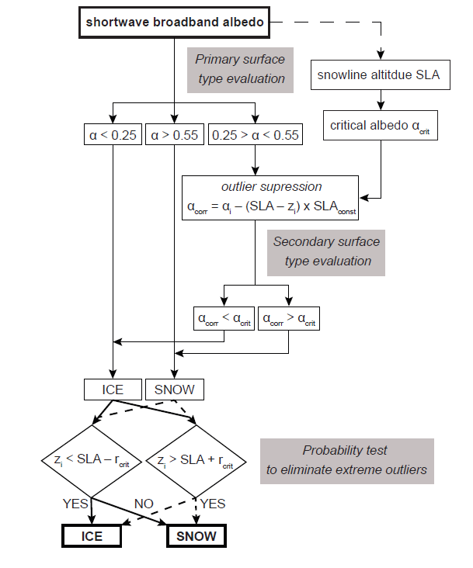

## Potential improvements:

Those two algorithms provide a good base on how to map the snow cover on ice. However, for the purpose to create a fully automated workflow, they can still be improved, depending on their performance and weaknesses. With the current knowledge, one point that can be investigated is the role of different bands and band combinations to maximize the contrast between snow and ice. The ASMAG uses only the NIR band while the algorithm by Naegeli looks at the broadband-albedo that is calculated, depending on the way of conversion, as a combination of different bands. It can be investigated if e.g. the approach by Rabatel et al using a combination of green, NIR and SWIR band yield a better snow-ice contrast that could improve the performance of e.g. the automated Otsu-thresholding or the approach by Naegeli based on the steepest slope of the Albedo as a first proxy for the SLA.

# 

# Methodology and current state of own research

The aim of this thesis is to implement, test and validate a fully automated processing framework that performs downloading, preprocessing and classification of snow on Swiss glaciers with Sentinel-2 data. So

## Sensor and Data

**Sentinel-2 Data:**

Sentinel- 2 is an ESA mission highly complementary to the USGS Landsat 7 and 8 data that has often been used in many scientific remote sensing applications. It consists of two satellites, Sentinel-2A and 2B that were launched in 2017. Together they have a revisiting time of 5 days at the equator with 13 different multispectral imaging (MSI) sensors ranging from Visible and Near-Infrared to shortwave infrared with a resolution of 10m to 60 m (see Figure xxx for an overview of the bandwidths of the Sentinel-2 bands)

https://esamultimedia.esa.int/docs/EarthObservation/Sentinel-2_ESA_Bulletin161.pdf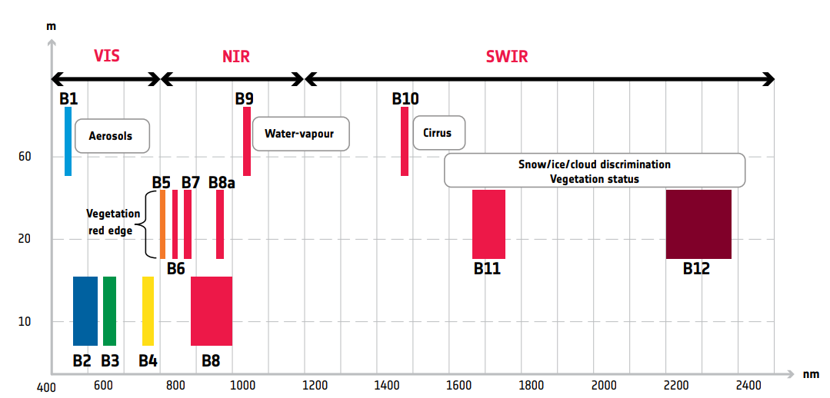

Spatial resolution versus wavelength of Sentinel-2 13 spectral bands. Source: https://esamultimedia.esa.int/docs/EarthObservation/Sentinel-2_ESA_Bulletin161.pdf

**Data retrieval/Download**

All Sentinel-2 Data products can be accessed for free in the Copernicus Open Access Hub with a user account. Users need to sign up for an account and can then sort the tiles by satellite, region, acquisition date, snow cover, processing format, etc. and then download the data in the .SAFE format as specified by ESA’s guidelines. Each data tile of 100km^2 x 100km^2 size in Level 2A has an approximate file size 0f 800 Mb.

Since this thesis aims to develop an automated processing framework that includes automatic data retrieval, the python API of ‘sentinelsat’ will be used to search the data and metadata for a given date and location and download it.

**Processing Levels and Data formats**

The Sentinel-2 Data is usually delivered in the SENTINEL-SAFE file structure, including image data in JPEG2000 format, quality indicators (e.g. defective pixels mask), auxiliary data and metadata. A detailed description of the file structure and content of the folder can be found in ESAs Technical Guide for Sentinel-2.

The Sentinel-2 Data is currently made available via the Sentinel Hub and AWS in two processing levels: Level 1-C data that gives radiometrically and geometrically corrected Top of Atmosphere (TOA) reflectance per pixel. The next higher level is the Level 2-A product where the output is an orthoimage Bottom-Of-Atmosphere (BOA) corrected reflectance product together with a scene classification map (details in the Sentinel-2 Technical Guide). It is possible to either retrieve the Level 2-A product directly in the .SAFE format or to process the Level 1-C data manually with the Sen2Cor module.

## Preprocessing:

To become familiar with the Sentinel-2 imagery and potential ways to process them using Python, a test set of level 2-A products was manually downloaded to perform some basic preprocessing and some tests.

**Glacier Mask**

In a first step, the outlines of the glaciers need to be extracted, so the algorithm does not map any snow cover or snow patches that are not on the glaciers. This is done by applying the newest glacier mask of the Swiss Glacier Inventory SGI from 2018. However, the SGI 2018 mask classifies many parts as glacier that on our satellite image clearly appear as dark areas, probably due to shadows or debris cover on the sides if the glaciers. Since those dark sides would significantly reduce the accuracy of our algorithm, we perform a second classification, based on the glacier mapping algorithm by Paul 2016 for the Swiss alps for Sentinel-2 Data. It classifies a pixel as part of the glacier when it meets all four criteria:

1. NDSI >= 0.20
2. 0 =< MSI4/MSI11 =< 2
3. MSI2/MSI4 =< 1.20

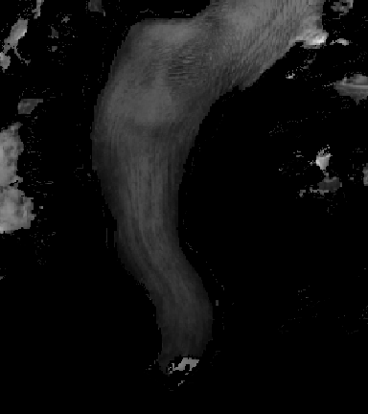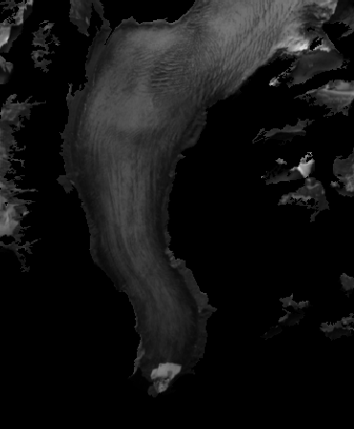

1. 0 =< MSI8/MSI11 =< 1.

Figure xxx a) shows the SGI glacier mask applied to a scene on Rhone Glacier in the NIR (Band 08) where the darker sides are still visible. Figure xxx b) shows the result after the thresholds have been applied, it can be seen that the darker side have successfully been removed.

However, since this will automatically exclude all shaded areas, we first want to apply the terrain correction before this thresholding is performed. Figure xxx shows a comparison of the SGI 2018 glacier mask in comparison with the

**Cloud Masks**

In a next step, a suitable cloud detection algorithm needs to be found.

Since the Swiss Alps are often affected by cloud cover that are opaque for optical sensors, a correct classification of clouds over the glaciers is very important. This is a rather problematic step since clouds and snow are very difficult to distinguish in the optical spectrum and therefore many available cloud mapping schemes widely overestimate cloud cover on snowy areas. However, for this thesis it is crucial to have a good cloud cover map so we the snow cover mapping can be performed successfully.

For the preliminary work, simply the cloud mask delivered by with Sentinel data on a 60m grid was used. It is based on a threshold applied to the blue B2 band and then the SWIR band B11 and B12 to take advantage of the differences in the spectral response of snow and clouds as described in the introduction (for details see Technical ESA report). On a test scene of Aletsch Glacier from October 2018, this algorithm already revealed its weakness: In any even slightly snowy area, the algorithm seems to fail and misclassify large cloud free and not even necessarily snow-covered areas as clouds. Coluzzi 2018 found similar problems in their study, suggesting using this cloud mask with precaution especially in Alpine environments.

Another approach that was briefly investigated is to use the scene classification that gets provided with the Level-2A products and extract a manual cloud mask from the scenes that got classified as either “Cloud Medium Probability”, “Cloud High Probability” or “Thin Cirrus”. From a visual inspection, the results are a lot better and more detailed, especially since they are provided with a 10 m resolution, so for a test run, this would be the required approach.

However, since the results of those two simple results are not very satisfying, other options must be explored. Sentinel Hub itself recognized the need for a good cloud classification algorithm and developed the machine learning based algorithm s2cloudless that performs significantly better than all other approaches, especially on snow. A python package to use with Sentinel-2 data containing the algorithm was released recently. During the proposal phase, the package still had some compatibility problems that could not be resolved so far, so simply the cloud mask based on the Level-2A scene classification was used but we hope to be able to employ the s2cloudless approach in our programming framework for the best possible performance.

Another point that needs to be considered is what maximum cloud cover on a scene can still be used for a successful classification. In general, a threshold-based method can be applied to any arbitrarily small, cloud free glacier part and therefore generate usable information on that part. However, when the algorithms become more complex and employ the glacier geometry such as the Naegeli’s approach, it is going to be challenging to produce meaningful results. The same applies for the Ostu-threshold-based ASMAG-algorithm that always assumes a bimodal snow-ice histogram which e.g. with a cloud cover over the entire snowy part of a glacier will lead to misclassification. Therefore, a certain limit to only include scenes with a lower cloud cover over each glacier must be found once the different algorithms are implemented.

## Terrain correction

Since the study site is naturally located in very steep terrain, the scenes are heavily affected by those shadows, producing very dark areas that can’t be accounted for by simply using band ratios for classification. Thus, a careful topographic correction will be a key to obtain a successful classification.

In theory, topographically corrected Sentinel-2 images are available with the Level-2A data. However, there is some unclarity on how this correction is performed in detail and the Sentinel-2 Handbook seems to be outdated on this information. It describes that the Level 2-A data are obtained manually on the user side by using the Sen2Cor package that performs atmospheric correction from Top-Atmosphere (TOA) to Bottom-of-Atmosphere (BOA) and an optional topographic correction whereas no information on what specific topographic correction is applied can be found anywhere. Those are based on the 90m SRTM Digital Elevation Database from CGIAR-CSI or the commercial 90m DTED-1 Format from PlanetDEM (Sen2Cor Handbook from June 2018). Since 2018, the Level 2-A data were systematically made available on the Copernicus Platform, but the product description has not changed, suggesting that the Level 2-A data that can be downloaded are only atmospherically but not topographically corrected. When looking at the data in mountainous terrain though, it can be seen that some kind of correction has been performed on the shaded areas, but the results are not very good. Paul 2016 already noted that the internal terrain correction for Sentinel-2 data was unsatisfactory for steep terrain. Figure xxx gives a comparison of the originally shaded terrain in the Level 1-C data and the Level 2-A data with the unsatisfactory unknown topographic correction.

Therefore, we will use the uncorrected Level 1-C data for this thesis and perform our own topographic correction. After Bippus 2011, the best terrain correction for mountainous areas is the Ekstrand correction that is widely used in pre-processing in applications for snow-ice mapping (Paul 2016, ASMAG algorithm by Rastner).

The Ekstrand correction is based on the solar illumination data of the acquisition date that is available in the Sentinel-2 metadata and aspect, slope and hillshade data derived from a DEM. For this application, the swissALTI 3D DEM with a 10 m resolution will be used. The corrected radiance of the horizontal surface is calculated as

L_h = L_in* (cos(Theta_z)…… include equation in LateX!

With the Minneart constant k that is obtained by linear regression of the logarithmic equation (Ekstrand 1995). Usually a global k-value is used for each scene, in case the results of this correction will not yet be able to achieve a successful classification, an approach by Lu, 2008, offering a pixel-based inversion method for the k-value is available to further improve the results if necessary.

For the terrain correction and the co-registration of the images, we will use the swissALTI3D DEM that is available for all of Switzerland with a resolution of 10 m.

## Alternative ideas:

Depending on how well the terrain correction will perform on the scene, potential other ways of dealing with the shadowed areas might have to be explored.

Apart from approaches such as a pixel-based methods for the k-value for a better terrain correction, Another possibility is to extract the shaded areas of the image based on the histogram and do a separate evaluation of the shadow-free and shaded areas. However, at this point it is not yet clear if such an approach will be necessary and will therefore not be yet be explored in detail.

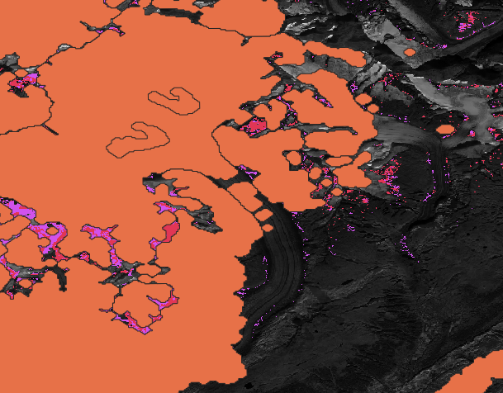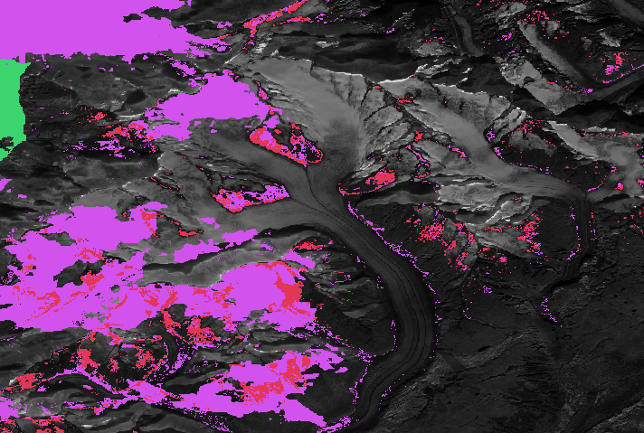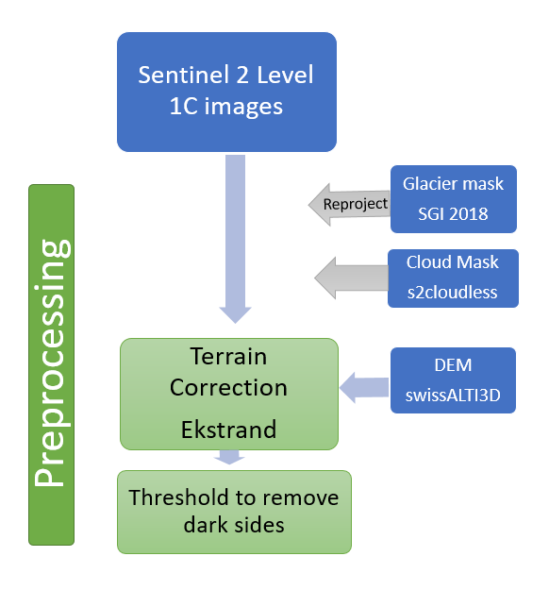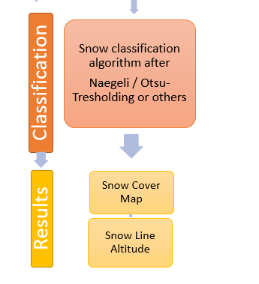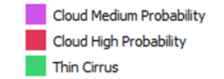

## Testing Algorithms

After the preprocessing, the actual classification of snow is applied to the scene. Since we did not include our DEM yet, no manual terrain correction was performed yet and no information about the SLA could be derived.

For a first test, we used as scene of Level-2A from October 17th, 2018 to perform some testing of the approaches of the different algorithms. The cloud mask used is based on the Level 2-A scene classification, the glacier mask is a combination of the SGI 2018 mask combined with the mixed thresholding based on Paul 2016.

Firstly, the Otsu-thresholding as used in the ASMAG algorithm was applied to an extract of the Große Aletsch Glacier of the NIR band (Band 08) to produce a first guess of a snow cover map (Figure 3.2). To avoid problems with the Otsu-algorithm and small glacier parts, the algorithm was simply applied to the entire scene.

Secondly, the narrow-to-broadband conversion as suggested by Naegeli 2017 based on Knap et al. was performed on band 08 and band 03 to obtain an albedo map with:

*a*Knap = 0.726b3 - 0.322b3^2 -0.015b8 + 0.581b8^2

On this shortwave albedo, the thresholds that discriminate between certainly ice (<0.25) and certainly snow (>0.55) were applied to create a map that represents the snow cover and the area on which the secondary surface type evaluation, shown in grey in figure 4.3. as described above, will be performed. However, since no DEM was used yet, we could not derive the estimate of the SLA and proceed with the classification.

The selected scene shows a rather “patchy” snow cover and contains a mixture of fresh snow and ice areas as well as firn while the tongue of the glacier is bare ice. This feature of the patchy snow cover is a major challenge in the proper classification of snow on glaciers, even with the bare eye it is often impossible to give a good estimate of the snow line since it is more of a gradual transition zone than a sharp line

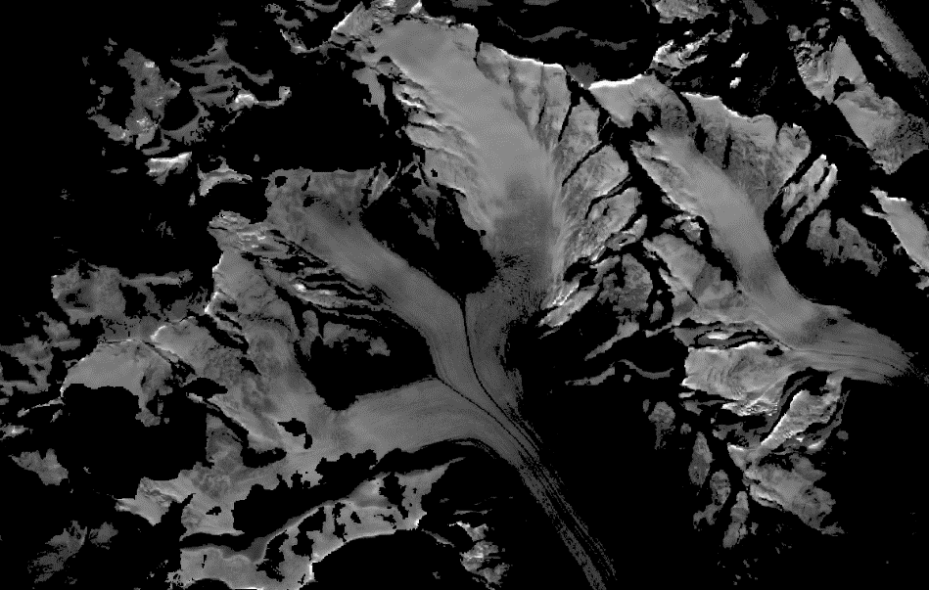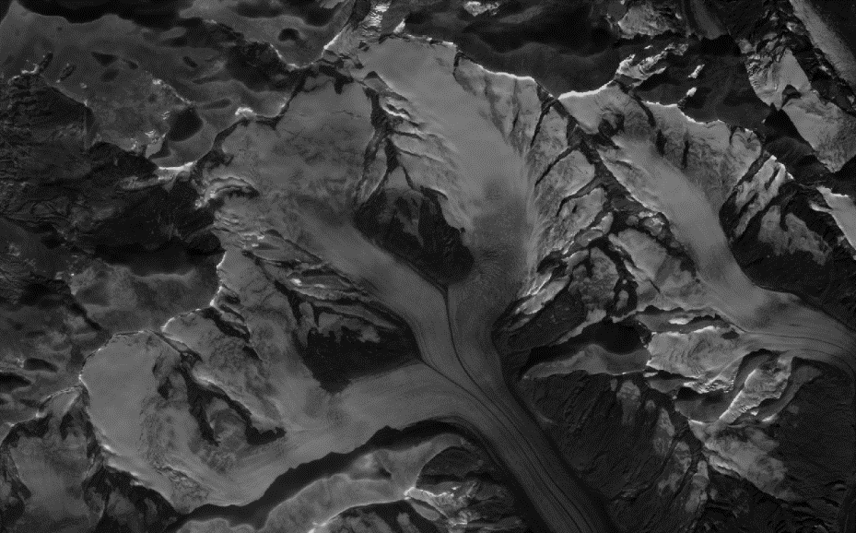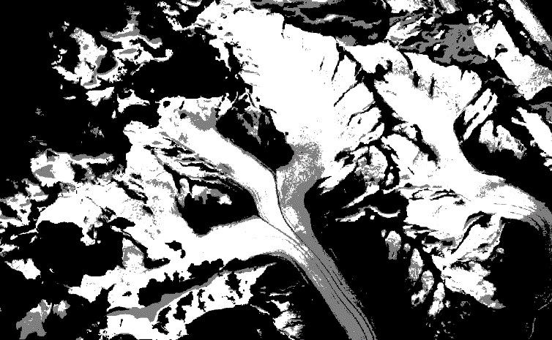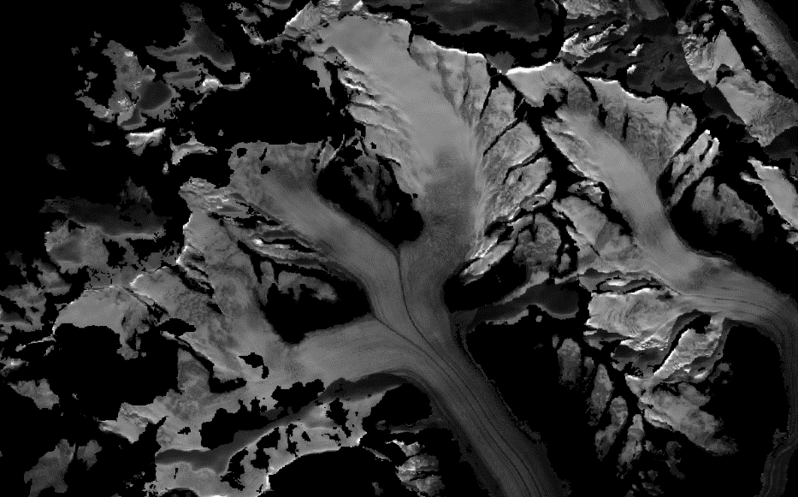

a) Band 08, Level 2-A Scene of Große Aletsch Glacier

b) Level 2-A Scene of Große Aletsch Glacier with applied cloud and glacier mask

c) Snow Cover after Otsu-Thresholding

d) Snow Cover after Albedo-Thresholding of Naegeli: white: certainly snow, gray: ambiguous area

However, several characteristics can be noted by visually inspecting the results:

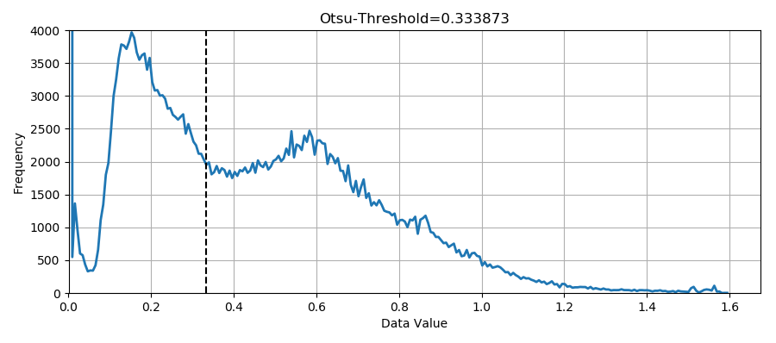The applied Otsu- algorithm performs a first-guess snow cover map for this scene, it classifies

60.3% of the glacier area as snow covered.

The histogram shows a bimodal histogram, with two peaks that probably belong for snow and ice, an Otsu-threshold of 0.33 is calculated. However, the snow threshold seems to be choosen too low, resulting in an overestimation of the snow-covered area. On the other hand, for the areas in the shadow on the north side of the ridgeline, we can see how the Otsu-threshold classifies a lot of the shaded areas as ice. This again stresses that the Level 2-A data is not appropriate for a successful classification and a better terrain correction is required.

e) shows the distribution after the albedo-thresholding as described by Naegeli, where white means “snow” and grey is the ambiguous range on which the secondary surface type will be performed. The area classified as certainly snow is 50.6% and the ambiguous area is 22.3% of the glacier area in this scene.

The albedo approach generally classifies a smaller area than the Otsu-algorithm as certainly snow, which is what would be expected. Since most of the ambiguous range (grey) is in the higher area of the glacier, the penalty function approach would most likely result in a classification of those as snow, which is correct for many places but also some bare ice areas will be misclassified with this method. The ambiguous range is quite high and without employing a DEM, no further estimation of how the final snow cover map would look like can be given.

Goal:

*List the main research question(s) you want to answer. Explain whether your research will provide a definitive answer or simply contribute towards an answer.*

This thesis will contain of three big parts. The goal of the first part is to implement the workflow presented so far into an automated object-oriented programming framework in python.

In a second step, the results should be validated against some manually classified scenes via a statistical analysis to give an answer to the question, which of the given algorithms provides the best results for high resolution snow cover mapping in an automated manner.

The third part of the thesis will be an analysis focusing on the spatio-temporal variability of the snow cover and snow line altitude will be performed, revealing trends in the cover of the Swiss alps as well as potential weaknesses/strengths of each algorithm.

A special focus will lie on the determination of uncertainties in each part of the processing workflow.

## Part 1: Creating automated object-oriented programming framework

The goal of the first part of the thesis is create a fully-automated programming framework in python. The requirements are that the code is set up in an object-oriented manner that can easily be adapted to work with different inputs. The code should will

1. Download and pre-process the Sentinel-2 images based on cloud cover, terrain corrections, etc. for all Swiss Glaciers as described in the Methodology
2. Retrieve a snow cover map and the snow line altitude by applying the algorithms presented by Rastner and Naegeli and possible improvements

The output will be binary snow cover maps and maps of the snow line altitude for each glacier. The goal is to implement several different algorithms to be able to evaluate their individual performances.

## Part 2: Validation of the algorithms

The obtained snow cover maps will be validated against a manually retrieved data set of the snow cover on the Swiss Glaciers. The validation data set needs to represent the variety of all Swiss glacier while over- or underrepresenting any characteristics. For a statistically relevant evaluation, a sufficiently big enough set of manually classified snow maps needs to be created. For this, data for the years of 2016-2018 between the months of May to October will be evaluated to create a wide temporal range and a randomly chosen data set out of all Swiss glaciers to cover a big spatial variety.

Since the SLA is a secondary product derived from the snow cover map, the validation of the latter needs to be prioritized. However, one this is performed, a validation of the derived SLA will still be conducted to evaluate the quality of the method to derive the SLA from the snow cover map. With those to steps, we can reveal the strengths and weaknesses of each of the implemented algorithm and therefore find the ones exhibiting the best performance for the automated classification of snow cover on the Swiss glaciers.

## Part 3: Analysis of spatio-temporal variability of the snow cover

With the retrieved data sets, an extensive spatio-temporal analysis of the snow cover of the Swiss glaciers will be performed. A general spatial analysis will reveal patterns on how the snow cover is distributed over the entire Swiss alps as well as e.g. on the North- and South-slope of individual glaciers. A temporal analysis will give information about how stable those patterns are, show how they change throughout the summer and between different years.

Furthermore, the SLA can be correlated to the mass balance on glaciers (Lliboutry (1965), Rabatel et.al, 2005, others). For this, the mass balance data of the Glacier Monitoring Network in Switzerland (GLAMOS) that are collected on a set of xx Swiss glaciers that are distributed as shown in Figure xxx will be employed. With this information, the correlation between our retrieved SLA data and the measured mass balances can be investigated.

The same approach can be applied for the runoff of the Swiss Glaciers. The Federal Office of the Environment (FOEN) closely monitors the Glacier runoff in Switzerland with a dense network (see Figure xxx for locations of available runoff data). This data can be compared to the obtained time series of snow cover maps and reveal potential correlations.

# Time Plan- Schedule and milestones

Please compile a schedule that includes the most important milestones.

*Give a detailed time plan. Show what work needs to be done and when it will be completed. Include other responsibilities or obligations.*

# Impact / Conclusion

*Explain what is striking/noteworthy about the results. Summarize the state of knowledge and understanding after the completion of your work. Discuss the results and interpretation considering the validity and accuracy of the data, methods and theories as well as any connections to other people’s work. Explain where your research methodology could fail and what a negative result implies for your research question.*

The goal of this thesis is to find a good method to automatically map snow cover on the Swiss Glaciers using optical Sentinel-2 images. No fully automated and validated method to map snow on glaciers with optical data in any part of the world has been developed yet, so the results of this work will have a big impact in this field.

With the rapidly increasing availability of high-quality remote sensing data, there is also a growing need for tools that perform automated processing and extraction of information for further scientific use. Therefore, this programming framework will lay its focus on an open source, object-oriented programming style so that the algorithm can easily be adjusted and utilized for many different applications.

The primary application this work is designed for is the CRAMPON project with its now-cast mass balance model for the Swiss alps that requires the automatically retrieved snow cover map for the model calibration.

In a second step we will reveal trends on the spatio-temporal variability of the snow cover on the Swiss Glaciers and correlate them with mass balance and glacial runoff data. Since no big-scale and long term analysis of the snow cover for the entire Swiss glaciers has been performed yet, we hope to be able to extract new information on the spatial distribution patterns of glacial snow cover and their temporal variability.

# Reference & Literature (Bibliography)

*List papers and publication you have already cited in your proposal or which you have collected for further reading. The style of each reference follows that of international scientific journals.*

## Challenges for automatization

To achieve step 2, a way to find other “possibly suitable algorithm” needs to be found.

The ASMAG algorithm that relies on detailed pre-processing and the flexible Otsu-algorithm to create a snow cover map and on the other hand the albedo-retrieval function by Naegli that uses a probabilistic penalty approach for the classification are two very different but both promising approaches that will provide a good base for this master thesis. Since an extensive statistical analysis on the suitability of the algorithms will be performed, it will be possible to test several other approaches as well, especially different band combinations. If we want to think about other potential approaches and specifically their suitability for automated implementation, we will have to think about the demands for such a potential algorithm. Most of the classification schemes for snow cover on ice so far have been applied manually or at least require supervision. Since this thesis aims to develop a fully-automated algorithm, we must guarantee that it will provide constant and reliable performance for all varieties of conditions and scenes that appear in the Swiss Alps without any human interaction.

To ensure this, we must carefully think about the variety of data that we have available, the spatio-temporal variability of their quality and what characteristics the classification must fulfil in our specific case:

This will include e.g.

* the relevance of cloud-free pixels: Does the glacier need to be 100% cloud-free or can we work with a certain percentage of cloud cover? How can we determine the critical cloud cover? What impact will cloud cover have on the performance of each approach (e.g. Otsu-Algorithm will most likely not provide useful results with high cloud cover, always assuming a bimodal histogram while simple band ratios probably still work with very high snow cover)?

Keeping those points in mind, we can implement different versions of the algorithms of Rastner and Naegeli, test the accuracy of the band combination used by Rabatel 2012a and find suitable band ratios and combinations to determine the best possible algorithm to detect snow cover on ice.